CSC 2400 / Chapter 3 Homework 3A

1. Give two examples of algorithms that are considered brute-force algorithms.
a. selection sort
b. sequential search
2. Sort the list E, X, A, M, P, L, E in alphabetical order by selection sort and bubble sort. Show each iteration.
Selection sort
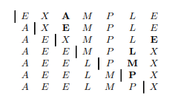
Bubble sort
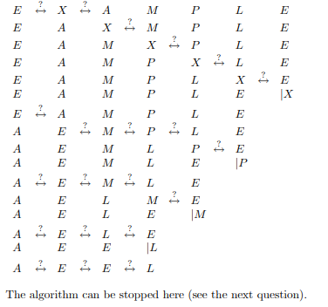

3. Below is an improved version of sequential search where we append the search key to the end of the list. This way, the search for the key will have to be successful, and therefore we can eliminate the end of the list check altogether. Use this algorithm to answer the questions that follow.
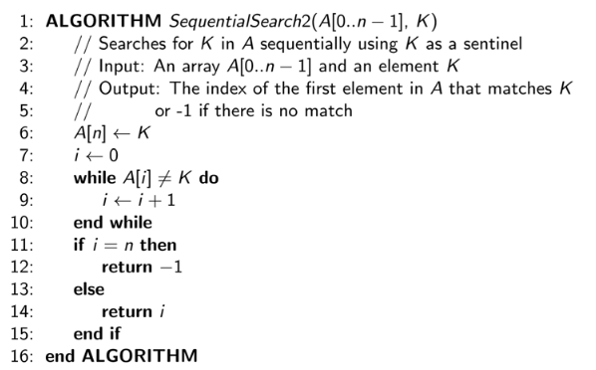
a. What is the problem size of this algorithm? n+1
b. What is the basic operation? T/F A[i] <> K
c. What would be the number of basic operations performed using worst-case? n+1

4. BRUTE FORCE STRING MATCHING:
a. Give an example of a text of length n and a pattern of length m that constitutes a worst-case input for the bruteforce string-matching algorithm.
text: aaaaaaaaaaaaaaaaaaaaaaaaaaaaaaaaa
pattern: aaaab
b. Exactly how many character comparisons will be made for such input?
n=33
m=5
C(n)=m(n-m+1)=5(33-5+1)=5*29 comparisons

5. What is the convex hull of the following sets and identify their extreme points:
a. A line segment :
the convex hull is the segment itself; the extreme points are the endpoints of the segment
b. A square
the convex hull is the square itself; the extreme points are corners (the vertices)

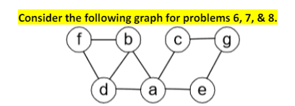
6. Write down the adjacency matrix and adjacency lists specifying this graph. Assume that the matrix rows and columns and vertices in the adjacency lists follow in the alphabetical order of the vertex labels.
a. ADJACENCY MATRIX:
a b c d e f g
a 0 1 1 1 1 0 0
b 1 0 0 1 0 1 0
c 1 0 0 0 0 0 1
d 1 1 0 0 0 1 0
e 1 0 0 0 0 0 1
f 0 1 0 1 0 0 0
g 0 0 1 0 1 0 0

b. ADJACENCY LIST:
a->b->c->d->e
b->a->d->f
c->a->g
d->a->b->f
e->a->g
f->b->d
g->c->e

7. Starting at vertex a and resolving ties by the vertex alphabetical order, traverse the graph by depth-first search and construct the corresponding depth-first search forest.

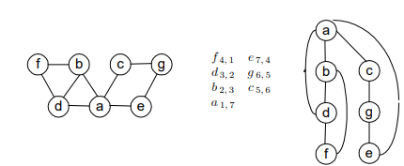

(a,d), (b,f) and (a,e) are back edges (should be dashed)

8. Traverse the graph by breadth-first search and construct the corresponding breadth-first search forest. Start the traversal at vertex a and resolve ties by the vertex alphabetical order.

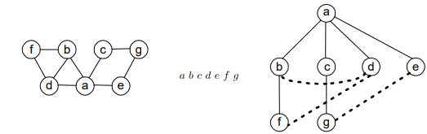

- If we define sparse graphs as graphs for which |E| ∈ O(|V |), which implementation of DFS will have a better time efficiency for such graphs, the one that uses the adjacency matrix or the one that uses the adjacency lists?
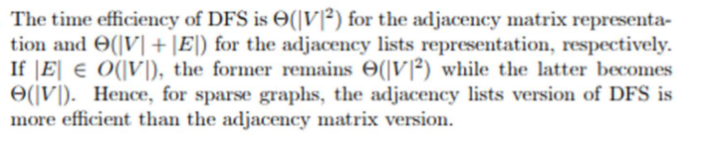

10.
